**Lab Assignment No: 09**

**NAME:** TAKANKHAR SHUBHAM

**ROLLNO:** 54

**SUBJECT CODE**: IT8002

**SUBJECT NAME**: CPP AND JAVA

**GR NO:** 119C0054

**BATCH:** B3

**PROBLEM STATEMENT:1**:- Apply Multiple Inheritance:  Derive Mtech student class from employee class  and student class

**CODE:**

#include<iostream>

using namespace std;

// Base class employee

class employee {

protected:

char empName[30];

int empId;

public:

void setEmployeeInfo()

{

cout << "Enter Employee Name: ";

cin.getline(empName,30);

cout << "Enter Emp. Id: ";

cin >> empId;

}

};

// Base class student

class student {

protected:

char studName[10];

int rollNo;

public:

void setStudentInfo() {

cout << "Enter Student Name: ";

cin.getline(studName,5);

cout << "Enter Rollno: ";

cin >> rollNo;

}

};

// Derived class

class mtech: public employee, public student {

public:

void getStudentDetails() {

cout << "Student Name: "<<studName;

cout << "Roll No.: "<<rollNo;

cout<<"\n";

}

void getEmployeeDetails(){

cout << "Employee Name: "<<empName;

cout << "Employee ID: "<<empId;

cout<<"\n";

}

};

int main(void) {

mtech stud1;

stud1.setStudentInfo();

cout<<"student details set!\n";

stud1.setEmployeeInfo();

cout<<"employee details set!\n";

cout<<"\n";

stud1.getEmployeeDetails();

cout<<"\n";

stud1.getStudentDetails();

char temp[10];

cin.getline(temp,10);

return 0;

}

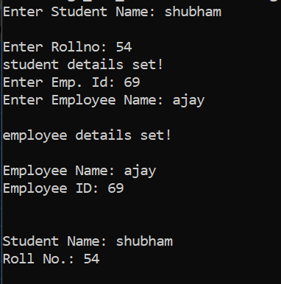

**PROBLEM STATEMENT:1** Heirarchical inheritance : to get square and cube of a number. Derive class square and cube from number class.

**CODE:**

#include <iostream>

**using** **namespace** std;

**class** Number

{

**private**:

**int** num;

**public**:

**void** getNumber(**void**)

{

cout << "Enter an integer number: ";

cin >> num;

}

**int** returnNumber(**void**)

{ **return** num; }

};

**class** Square:**public** Number

{

**public**:

**int** getSquare(**void**)

{

**int** num,sqr;

num=returnNumber();Number

sqr=num*num;

**return** sqr;

}

};

**class** Cube:**public** Number

{

**private**:

**public**:

**int** getCube(**void**)

{

**int** num,cube;

num=returnNumber();

cube=num*num*num;

**return** cube;

}

};

**int** main()

{

Square objS;

Cube objC;

**int** sqr,cube;

objS.getNumber();

sqr =objS.getSquare();

cout << "Square of "<< objS.returnNumber() << " is: " << sqr << endl;

objC.getNumber();

cube=objC.getCube();

cout << "Cube of "<< objS.returnNumber() << " is: " << cube << endl;

**return** 0;

}

